AARAA : A Movie Website



**Mini Project/Internship Assessment (BCS 554)**

**COURSE: B.Tech. SEMESTER:V**

**by**

**Madhav Pachaury (2200911530063)**

**Department of Computer Science and Engineering JSS ACADEMY OF TECHNICAL EDUCATION C-20/1, SECTOR-62, NOIDA December, 2023**

# VISION AND MISSION

VISION OF THE INSTITUTE

JSS Academy of Technical Education Noida aims to become an Institution of excellence in imparting quality Outcome Based Education that empowers the young generation with Knowledge, Skills, Research, Aptitude and Ethical values to solve Contemporary Challenging Prob-lems.

MISSION OF THE INSTITUTE

1. **Develop a platform for achieving globally acceptable level of intellectual acumen and technological competence.**
2. **Create an inspiring ambience that raises the motivation level for conducting quality re-search.**
3. **Provide an environment for acquiring ethical values and positive attitude.**

VISION OF THE DEPARTMENT

“To spark the imagination of the Computer Science Engineers with values, skills and creativity to solve the real-world problems.”

MISSION OF THE DEPARTMENT

1. **To inculcate creative thinking and problem-solving skills through effective teaching, learning and research.**
2. **To empower professionals with core competency in the field of Computer Science and Engineering.**
3. **To foster independent and lifelong learning with ethical and social responsibilities.**

## PROGRAM OUTCOMES(POs)

Engineering Graduates will be able to:

PO1: Engineering knowledge: Apply the knowledge of mathematics, science, engineering fundamentals, and an engineering specialization to the solution of complex engineering problems.

**PO2: Problem analysis: Identify, formulate, review research literature, and analyze complex engineering problems reaching substantiated conclusions using first principles of mathematics, natural sciences, and engineering sciences.**

PO3: Design/development of solutions: Design solutions for complex engineering problems and design system components or processes that meet the specified needs with appropriate consideration for the public health and safety, and the cultural, societal, and environmental considerations.

**PO4: Conduct investigations of complex problems: Use research-based knowledge and re-search methods including design of experiments, analysis and interpretation of data, and syn-thesis of the information to provide valid conclusions.**

**PO5: Modern tool usage: Create, select, and apply appropriate techniques, resources, and modern engineering and IT tools including prediction and modeling to complex engineering activities with an understanding of the limitations.**

PO6: The engineer and society: Apply reasoning informed by the contextual knowledge to assess societal, health, safety, legal and cultural issues and the consequent responsibilities relevant to the professional engineering practice.

PO7: Environment and sustainability: Understand the impact of the professional engineering solutions in societal and environmental contexts, and demonstrate the knowledge of, and need for sustainable development.

PO8: Ethics: Apply ethical principles and commit to professional ethics and responsibilities and norms of the engineering practice.

PO9: Individual and teamwork: Function effectively as an individual, and as a member or leader in diverse teams, and in multidisciplinary settings.

**PO10: Communication: Communicate effectively on complex engineering activities with the engineering community and with society at large, such as, being able to comprehend and write effective reports and design documentation, make effective presentations, and give and receive Clear instructions.**

**PO11: Project management and finance: Demonstrate knowledge and understanding of the engineering and management principles and apply these to one’s own work, as a member and leader in a team, to manage projects and in multidisciplinary environments.**

**PO12: Life-long learning: Recognize the need for, and have the preparation and ability to engage in independent and life-long learning in the broadest context of technological change.**

PROGRAM EDUCATIONAL OUTCOMES (PEOs)

PEO1: To apply computational skills necessary to analyze, formulate and solve engineering problems.

PEO2: To establish a entrepreneurs, and work in interdisciplinary research and development organizations as an individual or in a team.

PEO3: To inculcate ethical values and leadership qualities in students to have a successful career.

**PEO4: To develop analytical thinking that helps them to comprehend and solve real-world problems and inherit the attitude of lifelong learning for pursuing higher education.**

PROGRAM SPECIFIC OUTCOMES(PSOs)

PSO1: Acquiring in depth knowledge of theoretical foundations and issues in Computer Science to induce learning abilities for developing computational skills. PSO2: Ability to analyses, design, develop, test and manage complex software system and ap-plications using advanced tools and techniques.

## Course Outcomes(COs)

C340.1: Developing a technical artifact requiring new technical skills and effectively utilizing a new software tool to complete a task

C340.2: Writing requirements documentation, selecting appropriate technologies, identifying and creating appropriate test cases for systems.

C340.3: Demonstrating understanding of professional customs & practices and working with professional standards.

C340.4: Improving problem-solving, critical thinking skills and report writing. C340.5: Learning professional skills like exercising leadership, behaving professionally, behaving ethically, listening effectively, participating as a member of a team, developing appropriate workplace attitudes.

## CO-PO-PSO Mapping



**PO1 PO2 PO3 PO4 PO5 PO6 PO7 PO8 PO9 PO10 PO11 PO12 PSO1 PSO2**

|  |  |  |  |  |  |  |  |  |  |  |  |  |  |  |
| --- | --- | --- | --- | --- | --- | --- | --- | --- | --- | --- | --- | --- | --- | --- |
| **C340.1** | **3** | **3** | **3** | **3** | **2** | **3** | **3** | **3** | **3** | **3** | **2** | **3** | **3** | **3** |
| **C340.2** | **3** | **3** | **3** | **3** | **3** | **3** | **3** | **3** | **3** | **2** | **3** | **3** | **3** | **3** |
| **C340.3** | **2** | **2** | **3** | **3** | **3** | **2** | **3** | **3** | **3** | **1** | **2** | **3** | **3** | **3** |
| **C340.4** | **2** | **2** | **2** | **2** | **2** | **2** | **2** | **2** | **2** | **3** | **2** | **3** | **2** | **2** |
| **C340.5** | **2** | **2** | **2** | **2** | **2** | **2** | **2** | **2** | **2** | **3** | **2** | **3** | **2** | **2** |
| **C340** | **2.40** | **2.40** | **2.60** | **2.60** | **2.40** | **2.40** | **2.60** | **2.60** | **2.60** | **2.40** | **2.20** | **3.00** | **2.60** | **2.60** |

**DECLARATION**

**I hereby declare that this submission is my own work and that, to the best of my knowledge and belief, it contains no material previously published or written by another person nor material which to a substantial extent has been accepted for the award of any other degree or diploma of the university or other institute of higher learning, except where due acknowledgment has been made in the text.**

Name : Madhav Pachaury Roll. No. : 2200911530063

(Candidate Signature)

**CERTIFICATE**

**This is to certify that Mini Project/Internship Assessment Report entitled “AARAA : A Movie**

**Website” which is submitted by Madhav Pachaury in partial fulfillment of the requirement for the award of degree B. Tech. in Department of Computer Science and Engineering of Dr. APJ Abdul Kalam Technical University, Uttar Pradesh, Lucknow is a record of the candidate’s own work carried out by him/her under my supervision. The matter embodied in this report is original and has not been submitted for the award of any other degree.**

Signature

Name of Supervisor: Ms. Megha Gupta

Designation: Assistant Professor, JSS Academy of Technical Education, Noida

**Address: C-20/1, C Block, Phase 2, Industrial Area, Sector 62, Noida, Uttar Pradesh 201301**

Date: 07/12/2024

**ACKNOWLEDGEMENTS**

**I would like to express my sincere gratitude to all those who contributed to the successful completion of this report on the development of the “AARAA” a movie website. This endeavor would not have been possible without the unwavering support, guidance, and encouragement from various individuals and entities.**

**First and foremost, I extend my heartfelt thanks to JSSATE, NOIDA, where the training and project took place. The opportunity to work on the movie website project was invaluable, and I am grateful for the support and resources provided throughout the duration.**

**I would like to extend my sincere gratitude to Assistant Professor HOD in charge Ms. Megha Gupta for their invaluable guidance and instruction in LaTeX. Their expertise and dedication have equipped me with essential skills for crafting professional documents and have instilled in me a deeper understanding of the importance of clear and structured communication in academic and professional settings. The knowledge and confidence gained under their mentorship have significantly contributed to the quality and presentation of this project report. I am grateful for their unwavering commitment to our academic growth and success. I would like to acknowledge the entire project team for their collaboration and collective efforts.**

In conclusion, I acknowledge and appreciate the collective effort of everyone involved, directly or indirectly, in the realization of this Blog Website project and the subsequent report. Your contributions have left an indelible mark on this endeavor, and I am truly thankful for your support.

# ABSTRACT

**This report encapsulates the comprehensive exploration and development of a Movie Website, utilizing a spectrum of cutting-edge technologies and methodologies. The project was under-taken as part of a training program at JSSATE, NOIDA, with a primary focus on incorporating HTML, CSS, JAVASCRIPT, and JQUERY.**

**The report commences with an insightful introduction, elucidating the objectives, background, and the author’s role in the Movie Website project. A meticulous discussion on the selection of tools and technologies ensues, delving into the rationale behind opting for HTML, CSS, JAVASCRIPT, and JQUERY. An in-depth analysis, encompassing alternative technologies and a comparative study, offers a panoramic view of the technological landscape.**

**A movie website is an online platform dedicated to providing information, entertainment, and services related to movies. These websites serve as digital hubs for movie enthusiasts, offering a wide range of features and content. Web Application that has proper design and structure along with easy-to-use User Interface (UI) and a proper commenting system, which will let user to be more expressive.**

**The core of the report unfolds in the "Work Done" section, showcasing diagrammatic representations of the project, including use case diagrams and data flow diagrams. Modules within the app are discussed, accompanied by insightful screenshots that provide a visual narrative of the actual work done during the training. Each screenshot is dissected to elucidate the features of the technology, its application in the project, integration with other modules, and the associated inputs and outputs.**

**The concluding section delineates the key findings and outlines the future scope of the Blog Website. The report concludes by emphasizing the industrial and societal relevance and impact of the project. Additionally, it envisions the integration of the learned technologies and tools into the author’s final year major project.**

In essence, this report serves as a comprehensive documentation of the Blog Website development journey, shedding light on the intricate interplay of technologies, methodologies, and the project’s broader implications.

# LIST OF FIGURES

* 1. **Technologies . . . . . . . . . . . . . . . . . . . . . . . . . . . . . . . . . . .** **4**
  2. **Snapshots of the Website . . . . . . . . . . . . . . . . . . . . . . . . . . . . .** **11**
  3. **Code snippets of the Website . . . . . . . . . . . . . . . . . . . . . . . . . . .** **12**
  4. **Use Case Diagram . . . . . . . . . . . . . . . . . . . . . . . . . . . . . . . .** **13**
  5. **Zero Level Data Flow Diagram . . . . . . . . . . . . . . . . . . . . . . . . . .** **13**
  6. **First Level Data Flow Diagram . . . . . . . . . . . . . . . . . . . . . . . . . .** **14**
  7. **Second Level Data Flow Diagram . . . . . . . . . . . . . . . . . . . . . . . .** **14**

**Mini Project/Internship Assessment (BCS 554) (CSE V Semester)**

# TABLE OF CONTENTS

CHAPTER 1 INTRODUCTION

**CHAPTER 2 TOOLS & TECHNOLOGY USED**

**CHAPTER 3 HISTORY AND FEATURES OF THE TECHNOLOGY**

**CHAPTER 4 WORK DONE**

**CHAPTER 5 CONCLUSIONS AND FUTURE SCOPE**

# CHAPTER 1

**INTRODUCTION**

## Title: ‘AARAA’ A Movie Website.

Welcome to the immersive world of AARAA, where the magic of cinema comes alive! In this comprehensive report, we embark on a journey through the vast landscape of movies, exploring the latest trends, analyzing audience preferences, and delving into the intricacies of cinematic storytelling.

**As we navigate through the diverse realms of this ever-evolving industry, our report aims to shed light on key aspects that shape the cinematic experience on AARAA. From blockbuster hits that captivate global audiences to hidden gems waiting to be discovered, we delve into the heartbeat of cinema, bringing you insights that celebrate the art and craft of film-making.**

**The report details the technical aspects of the project, covering the implementation of Fron- tend Development, user interface design, and the integration of various technologies to achieve seamless user experience. The project aims to showcase the adaptability of Frontend Technologies for modern web applications. This report serves as a comprehensive exploration of the development process, challenges encountered, and the potential applications of the Frontend framework in creating responsive and interactive Movie Website.**

## My Role in the Project

**Within the project team, my role was multifaceted and instrumental to the project’s progression. As a key contributor, I actively engaged in various stages of the development life cycle. From conceptualization to implementation, debugging, and testing, my responsibilities encompassed a spectrum of tasks. The dynamic nature of my role allowed me to interface with different facets of the project, gaining insights into the complexities and nuances inherent in the website development.**

## Project Background and Goals-

**In the fast-paced digital era, the entertainment landscape has undergone a transformative evolution. The surge in online platforms for streaming movies has revolutionized how audiences access and engage with cinematic content. Recognizing this paradigm shift, AARAA aims to enhance the movie-watching experience by launching an innovative movie website**

**Goals: To provide a one-stop destination for a diverse collection of movies.**

To create a user-centric platform with personalized recommendations. To foster a community of engaged users through interactive features.

**To establish AARAA as a reputable and reliable source for quality cinematic content. In essence, this introduction sets the stage for the detailed exploration of the web development journey. The subsequent sections of this report will delve into the tools and technologies employed, the historical context of these technologies, the intricate work undertaken, and the far-reaching implications and future scope of the project.**

**CHAPTER 2**

**TOOLS & TECHNOLOGY USED**

**TOOLS:**

## Visual Studio Code (VS Code):

* **Explanation: Visual Studio Code is a free, open-source code editor developed by Microsoft. It is widely used for various programming languages and frameworks and is known for its versatility and lightweight design. VS Code provides features such as syntax highlighting, de-bugging support, intelligent code completion, and an extension system that allows developers to customize and extend its functionality.**
* **Alternative Technology/Tool: Before the widespread adoption of VS Code, developers often used text editors like Sublime Text or Atom, or fully-fledged IDEs like Eclipse or IntelliJ IDEA, depending on their specific needs.**
* **Why VS Code was Preferred:**
* **Versatility and Language Support: VS Code supports a wide range of programming languages, making it suitable for developers working on diverse projects.**
* **Extensibility: The extension marketplace allows developers to tailor VS Code to their specific requirements by adding extensions for languages, frameworks, and tools.**
* **Lightweight: Compared to some heavier IDEs, VS Code is lightweight, providing a balance between functionality and resource efficiency.**
* **Comparative Study**

## Advantages:

* **Versatility: VS Code is not tied to a specific platform or language, making it suitable for a broad range of development tasks.**
* **Community Support: A large and active community contributes to a vast selection of extensions and plugins, enhancing functionality.**
* **Ease of Use: Its intuitive interface and straightforward setup make it accessible to developers with varying levels of experience.**

## Disadvantages:

* **Lack of Built-in Android Support: Unlike Android Studio, VS Code does not provide dedicated support for Android app development out of the box.**
* **Not a Full-fledged IDE: While it provides robust features, it may lack some of the advanced tools specific to certain IDEs.**

# TECHNOLOGIES:

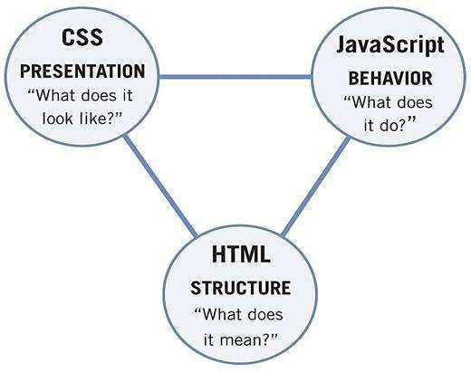

Figure 2-1: Technologies

# HTML :

* **Explanation: HTML, or Hypertext Markup Language, is the standard language used to create and design documents on the World Wide Web. It serves as the backbone of web content, providing a structured way to format and present information on web pages.**
* **Alternative Technology/Tool:**

**An alternative technology to HTML for structuring and presenting web content is Markdown.**

Why HTML was Preferred:

* **It is universally supported by web browsers, ensuring consistent rendering across different platforms and devices.**
* **HTML is designed to be backward compatible, meaning newer versions still support the features of previous versions.**

## Advantages:

**HTML has a straightforward and easy-to-learn syntax, making it accessible for beginners in web development.**

**HTML supports a wide range of elements, allowing developers to create diverse types of content.**

## Disadvantages:

**HTML is primarily a markup language for structuring content, and it has limited styling and layout capabilities.**

**Lack of Interactivity.**

# CSS :

* **Explanation CSS, or Cascading Style Sheets, is a stylesheet language used to describe the presentation and styling of a document written in HTML or XML. It separates the structure and content of a web page from its visual representation, allowing developers to control the layout, design, and appearance of web content.**
* **Alternative Technology/Tool: An alternative technology to CSS is Sass (Syntactically Awe-some Stylesheets).**
* **Why HTML was Preferred:**
* **CSS provides a consistent way to style and format elements across a website. This consistency is crucial for creating a cohesive and professional-looking user interface**.

## Advantages:

* **CSS allows for the consistent styling of elements across an entire website.**

## Disadvantages:

* **Achieving consistent styling across different web browsers can be challenging.**

JAVASCRIPT:

**Explanation JavaScript is a versatile and widely used programming language that primarily runs in web browsers, enabling developers to create dynamic and interactive web pages.**

* **Alternative Technology/Tool: An alternative technology to JAVASCRIPT is TYPESCRIPT or DART.**
* **Why HTML was Preferred:**
* **JavaScript is supported by all major web browsers, including Chrome, Firefox, Safari, Edge, and others.**
* **JavaScript is specifically designed for client-side scripting, allowing developers to create dynamic and interactive user interfaces.**

## Advantages:

* **It enhances the user experience by enabling real-time updates, form validation, and asynchronous operations without requiring page reloads.**
* **JavaScript supports both object-oriented and procedural programming paradigms, making it a versatile language. Developers can choose the programming style that best suits their project**

requirements.

## Disadvantages:

* **Since JavaScript code is executed on the client side, it is inherently less secure than server-side code.**
* **JavaScript runs in a single thread within the browser, which can lead to performance issues for computationally intensive tasks.**

# CHAPTER 3

**HISTORY AND FEATURES OF THE TECHNOLOGY**

## History of the Technology Used

HTML5(Hyper Text Markup Language):

* **HTML was created by Sir Tim Berners-Lee in 1991. It had a basic set of tags for structuring documents, including headings, paragraphs, links, and lists.**
* **Hypertext Markup Language, is the standard markup language for documents designed to be displayed in a web browser.**
* **HTML has evolved to become the backbone of the World Wide Web, providing a standardized way to create and structure content for the internet.**

CSS(Cascading Style Sheet):

* **First CSS was introduced in December 1996 by the World Wide Web Consortium (W3C).**
* **It is used for describing the look and formatting of a document written in HTML or XML.**
* **It is used for providing powerful tools for creating complex and responsive layouts.**

JavaScript:

* **JavaScript was created by Brendan Eich in 1995.**
* **JavaScript is a high-level, interpreted programming language that is primarily known for its use in web development to enhance the interactivity and dynamic behavior of web pages.**
* **Today, JavaScript is a fundamental technology for web development, and it has expanded beyond the browser with the development of server-side JavaScript (Node.js) and its use in various application frameworks and libraries.**

Visual Studio Code (Integrated Development Environment):

* **Developed by Microsoft and released in 2015.**
* **Quickly became one of the most popular and widely used code editors.**
* **Known for its speed, extensibility, and robust support for various programming languages.**

## Features of the Technology Used

HTML5(Hyper Text Markup Language):

* **It Provides Structure to the Website.**
* **HTML5 has new input types to improve the user experience and facilitate more accurate data input.**
* **It has features for creating a website responsive that adapt to different screen sizes and devices.**
* **It has Improved Accessibility features that enhances the accessibility of web content making it more usable for people.**

CSS(Cascading Style Sheet):

* **It is a Powerful Styling Language that enables web developers to control the presentation and layout of HTML document.**
* **Provides Control over text properties.**
* **Provides you the responsiveness in website with media query.**

JS(JavaScript):

* **It is a versatile programming language primarily used for building dynamic and interactive web applications.**
* **Used as a client-side scripting language.**
* **Supports asynchronous programming crucial for handling tasks such as fetching data from a server.**

Visual Studio Code (Integration Development Environment):

* **Extensibility: A wide range of extensions available for language support and additional features.**
* **Intelligent Code Completion: Assists developers with suggestions and autocompletion.**
* **Integrated Terminal: Allows running terminal commands directly within the IDE.**

**Mini Project/Internship Assessment (BCS 554) (CSE V Semester)**

# CHAPTER 4

**WORK DONE**

## Diagrammatic Representation of the Project

1. **Frontend**
2. **Code Snippets of the website**
3. **Use Case Diagram**
4. **Data Flow Diagram**
   1. **FRONTEND:**

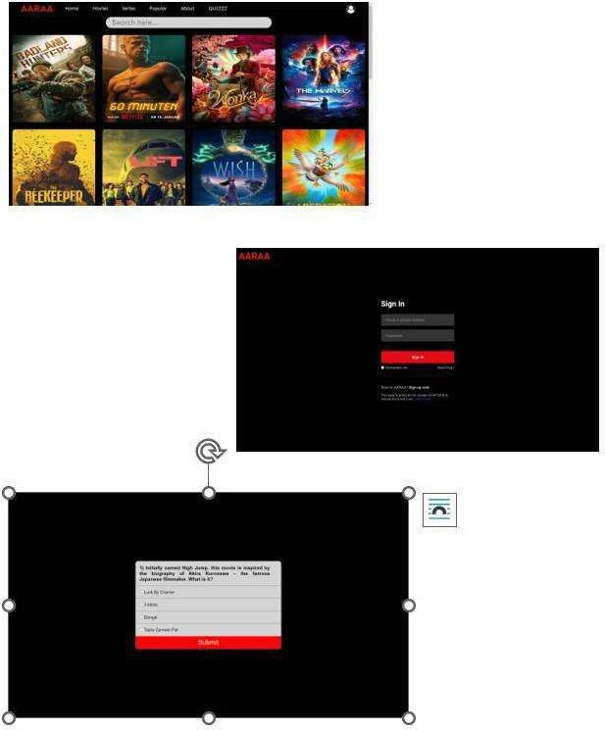

Figure 4-1: Snapshots of the Website

* 1. **CODE SNIPPETS:**

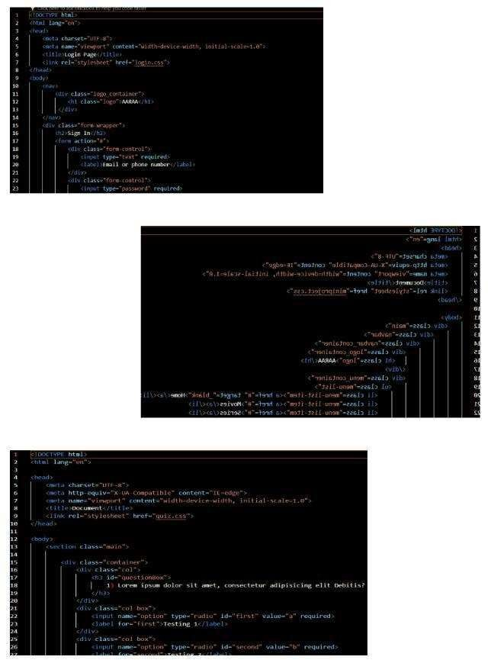

Figure 4-2: Code snippets of the Website

* 1. **USE CASE DIAGRAM:**

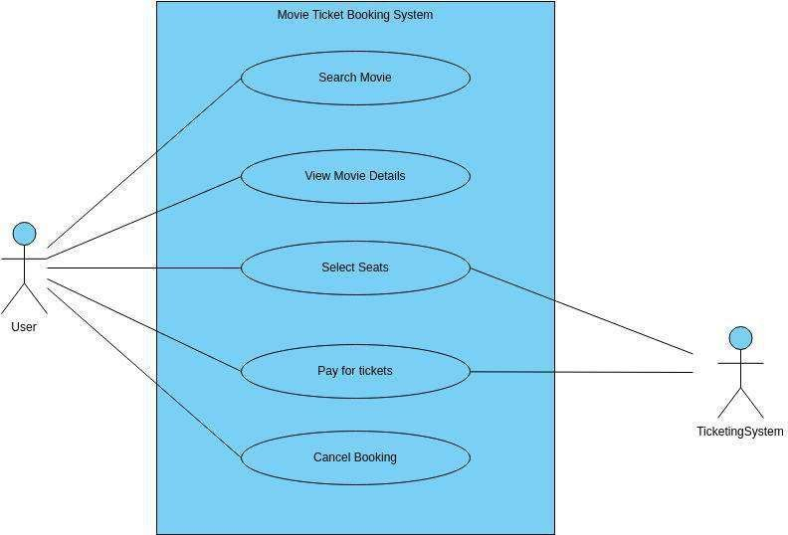

Figure 4-3: Use Case Diagram

* 1. **DATA FLOW DIAGRAM:**

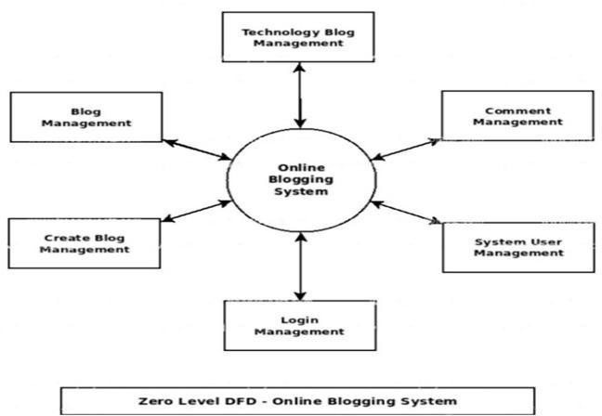

Figure 4-4: Zero Level Data Flow Diagram

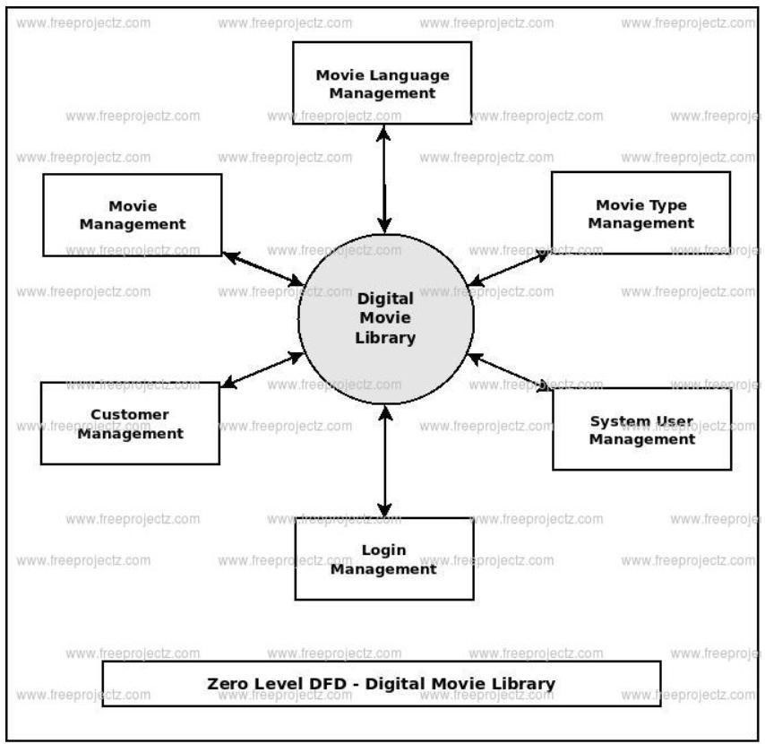

Figure 4-5: First Level Data Flow Diagram

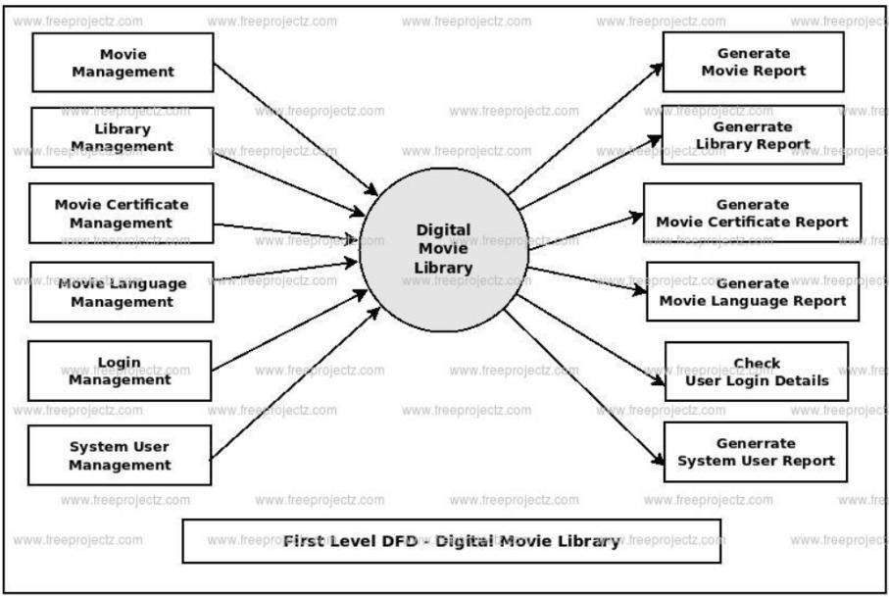

Figure 4-6: Second Level Data Flow Diagram

# CHAPTER 5

**CONCLUSIONS AND FUTURE SCOPE**

## Concluding the Movie diagram Project

**The development of the blog website “AARAA”, utilizing a stack of technologies including HTML, CSS, JAVASCRIPT and JQUERY, has been a significant learning experience. As the project concludes, it’s essential to reflect on the achievements and how the acquired knowledge can be leveraged for future endeavors. The culmination of the web designing project, utilizing a powerful stack of technologies including HTML, CSS, JAVASCRIPT and JQUERY, marks a significant milestone in the realm of digital web development. As we draw conclusions from this endeavor, it is crucial to reflect on the achievements and consider how the acquired knowledge can be harnessed for future endeavors.**

## Utilization in the Final Year Major Project

**The technologies and tools employed in this project lay a solid foundation for broader applications, making them ideal candidates for incorporation into the final year major project. The robust frontend built with HTML, CSS, JAVASCRIPT and JQUERY demonstrates a versatile and scalable architecture. Leveraging these technologies in the major project ensures a stream-lined and efficient development process.**

## Industrial Relevance

**The technologies employed in the web development hold substantial industrial relevance:-**

Enhanced Online Presence:

**In today’s digital age, having a strong online presence is crucial for businesses. A well- executed web development project can lead to the creation of a professional and user- friendly website, serving as a key touchpoint for customers, clients, and stakeholders.**

Increased Accessibility and Reach:

A web development project can make products, services, or information more accessible to a global audience. This increased reach can open up new markets, attract diverse customers, and contribute to business growth.

Efficient Business Operations:

**Implementing web-based solutions can streamline internal processes, improve communication, and automate repetitive tasks. From content management systems (CMS) to custom web applications, these solutions can enhance overall operational efficiency within an organization.**

E-commerce Capabilities:

**For businesses involved in retail, a web development project that incorporates e-commerce functionality can significantly expand sales channels. Online stores enable seamless transactions, customer engagement, and personalized shopping experiences.**

Data Analytics and Insights:

Web development projects often involve the integration of analytics tools. This allows businesses to gather valuable data on user behavior, preferences, and trends. Analyzing this data can inform strategic decisions and marketing efforts. • Societal Relevance and Impact:

**The Blog Website, as a tool for seamless blog-making and organization, carries societal relevance by catering to the digital needs of users. The project’s impact is not limited to individual productivity; it extends to fostering efficient communication and collaboration. The secure user authentication ensures data privacy, aligning with societal expectations for robust security measures in digital applications.**

# FUTURE SCOPE:

**As the movie industry continues to transcend geographical boundaries, AARAA envisions a strategic expansion into international markets. By securing licensing agreements with filmmakers worldwide, we aim to diversify our content library, providing users with access to a rich tapestry of global cinema. This expansion will not only cater to a broader audience but also contribute to cross-cultural appreciation and understanding. Here are several aspects to**

consider regarding the future scope of this website:

Integration of Emerging Technologies:

The future of entertainment lies in embracing cutting-edge technologies. AARAA is committed to staying at the forefront of innovation by exploring the integration of emerging technologies such as virtual reality (VR) and augmented reality (AR). These advancements will elevate the user experience, offering immersive and interactive elements that redefine how audiences engage with cinematic content. Enhanced User Engagement:

The future success of AARAA hinges on continuous user engagement. We plan to implement features such as live events, interactive watch parties, and exclusive behind-the-scenes content. By fostering a sense of community and shared enthusiasm for cinema, we aim to create a dynamic platform where users not only consume content but actively participate in shaping the movie- watching experience. Mobile Optimization:

With the increasing use of mobile devices, the future scope involves optimizing movie websites for mobile platforms. Responsive design, mobile-friendly interfaces, and app development may become even more crucial for reaching a wider audience. Voice Search Optimization:

**As voice-activated devices and voice search continue to gain popularity, movie websites may need to optimize content for voice search queries. This involves considering natural language patterns and long-tail keywords that align with spoken search queries.**

# REFERENCES

* + **HTML Documentation from MDN Web Docs**
  + **CSS Documentation from MDN Web Docs**
  + **JavaScript Documentation from MDN Web Docs**
  + **W3Schools.com**
  + **Using Wikipedia for project image.**
  + **Video tutorials by Awa Melvine**
  + **Font Awesome for icons**
  + **ckeditor.com/docs for feature rich JavaScript text editor**